‘Abduh, Muhammad (1849- 1905)
Yaser Mirdamadi, University of Edinburgh

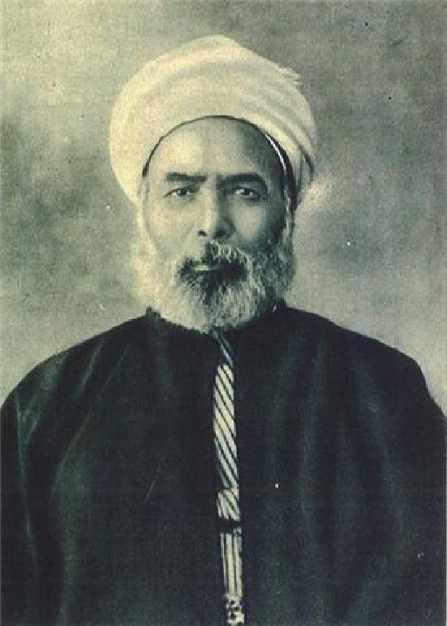
SUMMARY
Muhammad ‘Abduh
url: http://www.al-ahkam.net/home
/sites/default/files/muhamad_abduh.jpg

Muhammad ‘Abduh, along with Jamal al-Din al-Afghani (1838/9-1897) are widely considered as the co-founders of Muslim modernism, mainly in, though not confined to, Sunni Islam. An Egyptian jurist, theologian, exegete, grand mufti (Islamic legal counselor) of Egypt, journalist and liberal religious reformer, he had a considerable role in modernisation of al-Azhar, the most important centre of Islamic learning in Sunni Islam and in Islamic activism in the whole Muslim world. He left a diverse and even seemingly paradoxical legacy behind himself, ranging from salafism to liberalism.

MAIN ENTRY
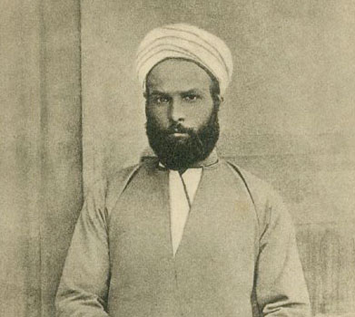
‘Abduh in his youth
url:http://www.britannica.com/biography/Muhammad-Abduh
Muhammad ‘Abduh was born in Lower Egypt to a peasant family. He learnt the Qur’an by heart in his adolescence and eventually found his way to the al-Azhar mosque in Cairo, the most important centre of Islamic learning in Sunni Islam. He met Jamal al-Din al-Afghani in 1872 in Egypt. Al-Afghani exerted a lasting influence on him; through al-Afghani ‘Abduh, despite his ascetic and seclusive tendencies at that time became sensitive to the social and political problems of Muslim world and became familiar with western philosophy and modern science. After graduating from al-Azhar in 1877, he started teaching and embarked on journalistic activities. In 1880 he was appointed as the chief editor of the Official Egyptian Gazette, al-Waqaʾiʿ al-Misriyya (The Egyptian News) through which he promulgated liberal Islam. In 1882 he went into forced exile due to his political activities against the British occupation of Egypt. In 1884 he joined al-Afghani in Paris, where they founded a society called al-‘urwat al-Wuthqa (the firmest bond) and published an influential and revolutionary journal with the same name. In 1889 he returned to Cairo, gradually acceding tothe highest clerical position in Egypt, the great mufti (Islamic legal counselor), which he held until his death in 1905. In this post he endeavored to reform the administration of the shari‘a (Islamic law) and the education of jurists. He also lectured at al-Azhar and contributed to the reformation of its curriculum, encouraging the introduction of modern sciences along with traditional sciences into al-Azhar University.

In his position regarding theological issues, mainly reflected in his well-known treatise ‘The Theology of Unity’ (1897), ʿAbduh strived to demonstrate the compatibility and harmony of reason and revelation, and the freedom of the will and the centrality of ethical values. He condemned taqlid, the uncritical submission to established doctrines and customs, and demanded the restoration of ijtihad, the critical and innovative approach toward religious issues. He also called Muslims to return to the original and authentic Islamic forefathers (salafs), as epitomised in the early Islamic period (especially Muhammad’s own period and the period of the four caliphs immediately after him), arguing that this return would guarantee the appropriation of modern scientific culture. In his book Islam and Christianity on Science and Civilization (1902) he compared and contrasted Christianity and Islam concluding that Islam, due to its rationality, is more adaptable to modern science and modern society than Christianity.

In matters of Islamic law, in which a jurist addresses both personal and social, sacred and secular affairs, ʿAbduh, as a great jurist and mufti, opposed the rigid formalism prevalent among jurists and tried to promote ethical goals such as equity and well-being, upon which Islamic law is to based even at the price of going beyond the literal meaning of the Qurʾan. For example, he permitted Muslims to eat meat slaughtered by Jews and Christians, a fatwa that is not common even today, more than a century after ‘Abduh, among Muslim jurists.

Since the middle of 1890’s his reformist approach departed from that of his mentor al-Afghani; while the latter had a revolutionary approach toward colonialism and despotism of unjust rulers and was content with nothing less than a thorough upheaval in Muslim countries, ‘Abduh gradually inclined to piecemeal reform, especially through the improvement of religious education and legal institutions.

The legacy of ‘Abduh turned out to be diverse and even seemingly paradoxical. Rashid Rida (1865-1935), Abduh’s Syrian pupil, highlighted and elaborated the salafi threads of his mentor’s thought while Ghasem Aimn (1863-1908) his Egyptian pupil, among others, elaborated the liberal threads of ‘Abduh’s thought.

Biography
1849: Born in Lower Egypt
1862: Starts his theological study at the theological school in Tanta, but left it soon.
1866: The start of his study at the al-Azhar mosque in Cairo
1872: Met Jamal ad-Din al-Afghani who exerted a lasting influence on him
1877: Graduates from al-Azhar.
1879: loses his teaching job.
1880: is appointed as the chief editor of the Official Egyptian Gazette, al-Waqaʾiʿ al-Misriyya.
1882: Is exiled from Egypt due to his political activities.
1884: Joins briefly al-Afghani in Paris and they co-found al-‘urwat al-Wuthga.
1885: Moves to Beirut. This move would effectively also mean a break with al-Afghani.
1888: Is permitted to return to Egypt, and begins a judicial career.
1891: Is appointed judge at the Court of Appeal.
1894: Becomes a member of the supreme council of al-Azhar.
1899: After gradually changing his views on foreign influence on Egypt, Abduh becomes mufti of Egypt as a result of help from the British.
1905 July 11: Dies near Alexandria.

List of his works:

(1993) Muhammad ‘Imarah, ed., al-A‘mal al-kamilah li’l Imam Muhammad ‘Abduh [Complete Works of Muhammad ‘Abduh], 5 volumes (Cairo: Dar al-Shuruq).
(1874) Risalat al-Waridat (‘Abduh’s edition of al-Afghani’s lessons in Islamic mysticism).
(1876) Has̲h̲iya ʿala Sh̲arh al-Dawani li ’l-ʿaqaʾid al-ʿadudiyya, Cairo (‘Abduh’s critical edition of al-Afghani’s private lessons in Islamic theology).
(1885) Sharh Nahj al-Balagha.
(1902) al-Islam wa ’l-Nasraniyya maʿa ’l-ʿilm wa ’l-madaniyya (Islam and Christianity on Science and Civilization) (1902) .
(1903) Tafsir Surat al-‘Asr.
(1904) Tafsir juz’ ‘Amma, al-Matb. al-Amiriyya.
(1927) Tafsir Manar, 12 volumes.
(1954-1961), Tafsir al-Qur’an al-Hakim al-Mustahir bi Tafsir al-Manar, 12 vols. with indices.
(1962 or 1963), Fatihat al-Kitab.
(no date) Durus min al-Qur’an al-Karim, ed. by Tahir al-Tanakhi, Dar al-Hilal.
(1966) The Theology of Unity, trans. by Ishaq Musa'ad and Kenneth Cragg.

Further Reading

Sedgwick, Mark. Muhammad Abduh. London: Oneworld, 2010.

Abu Zayd, Nasr. Reformation of Islamic Thought, A Critical Historical Analysis. Amsterdam: Amsterdam University Press, 2006.

Schacht, J. "Muhammad ʿAbduh." Encyclopaedia of Islam, Second Edition. Edited by: P. Bearman, Th. Bianquis, C.E. Bosworth, E. van Donzel, W.P. Heinrichs. Brill.

